**NAME :**

RATHOD PURVI

**SUBJECT :**

SOFTWARE TESTING

**Software Testing Assignment**

**Module 1 (fundamental)**

**Solution**

**1.what is SDLC?**

Answer : SDLC full form is **software development life cycle**.there is a different development models. SDLC is structure imposed on the development of a software product difines of planning, implementation, testing, documentation and going maintenance and support.

**2.what is testing ?**

Answer:testion is proccess identify the **correctness, completeness and quality** of developed computer softwer.

**3.what is agile methodology?**

Answer:basically agile methodology combination of **iterative** **and** **incremental** process model.agile process had started early in thee software development.

**4.what is SRS?**

Answer:SRS is full form is **software** **requirement** **specification.** SRS is a computer description of the behaviour of the system to be developed.

**5.what is OOPS ?**

Answer: OOPS full form is oriented programming . identifying objects and assigning responsibilities to these objects.

**6.write basic concepts of OOPS**

Answer: basic concepts of OOPS is following :

* **Object**: any entity which has a own behviour and state

Ex: laptop

* **Class**: collection of objects

Ex:group of laptops

* **Abstraction**:higing internal details & showing funcationally

Ex: laptop login page

* **Encapsulation**: wrapping up of data or binding of data

Ex: capsule

* **Inheritance**: when one object acquire all the properties behaviour of parent class

Ex: father and son

* **Polymorphism**: many ways to perform anything

Ex: method overloading

Ex: method overriding

**7.what is object ?**

Answer: any entity which has a own state & behaviour.

Ex : Pen , Paper , Chair etc……

**8.what is encapsulation?**

Answer: wrapping up of data or binding of data

Ex: capsule

**9.what is inheritance?**

Answer: when one object acquire all the properties & behaviour of parent class

Ex: father and son

**10.what is polymorphism?**

Answer: many ways to perform anything

Ex: Method overloading

Method overriding

**11.write SDLC phases with basic introduction**

Answer :

|  |  |  |
| --- | --- | --- |
| NO | Phases | Introduction |
| 1 | Requirements | Know customer needs |
| 2 | analysis | Model requirments : “**WHAT**” |
| 3 | Design | Solution : “**WHY**” |
| 4 | implementation | Construct a solution in software |
| 5 | testing | Solution against the requirements |
| 6 | maintenance | Repair defects and adapt the solution to the new requirements |

**12.explain phases of the waterfall model**

Answer : waterfall model’s second name is classical software cycle . the classical software software development life cycle models the software development as a step by step “waterfall”between the various development phases.

**13.write a phase of spiral model**

**ANSWER:**

|  |  |  |
| --- | --- | --- |
| No | phase | introduction |
| 1 | planning | Determination of objects, alternatives and constaints |
| 2 | Risk analysis | Analysis of alternative and identification or resolution of risks |
| 3 | Engineering | Development of the “next leval” product |
| 4 | Customer evalution | Assessment of the results of engineering |

**14. write agile manifesto principles**

Answer: agile model believes that every project needs to be handled differently and the existing methods need to be tailored to best suit the project requirements. Agile SDLC model is a combination of iterative and incremental process model with focus on process adeptlity and customer satisfaction by rapid delivery of working software product.

**15.explain working methodology of agile model and also write pros and cons.**

Answer : basic concept of agile model : agile model believes that every project needs to be handled differently and the existing methods need to be tailored to best suit the project requirements. Agile SDLC model is a combination of iterative and incremental process model with focus on process adeptlity and customer satisfaction by rapid delivery of working software product. Agile thought process had started early in the software development and started becoming popular with time due to its flexibility and adaptblity.

Here is some pros and cons of agile method ;

|  |  |  |
| --- | --- | --- |
| NO | PROS | CONS |
| 1 | Teamwork and cross training | More risk of sustainability |
| 2 | Suitable for fixed or changing requirements | Handling complex dependencies |
| 3 | Little or no planning required | There is very high individual dependency, since there is minimum documentation generated |
| 4 | Easy to manage | Depends heavily on customer interaction. |

* **SOME USE CASE MENTIONED HERE :**

**16.draw a Usecase on Online Book shopping**

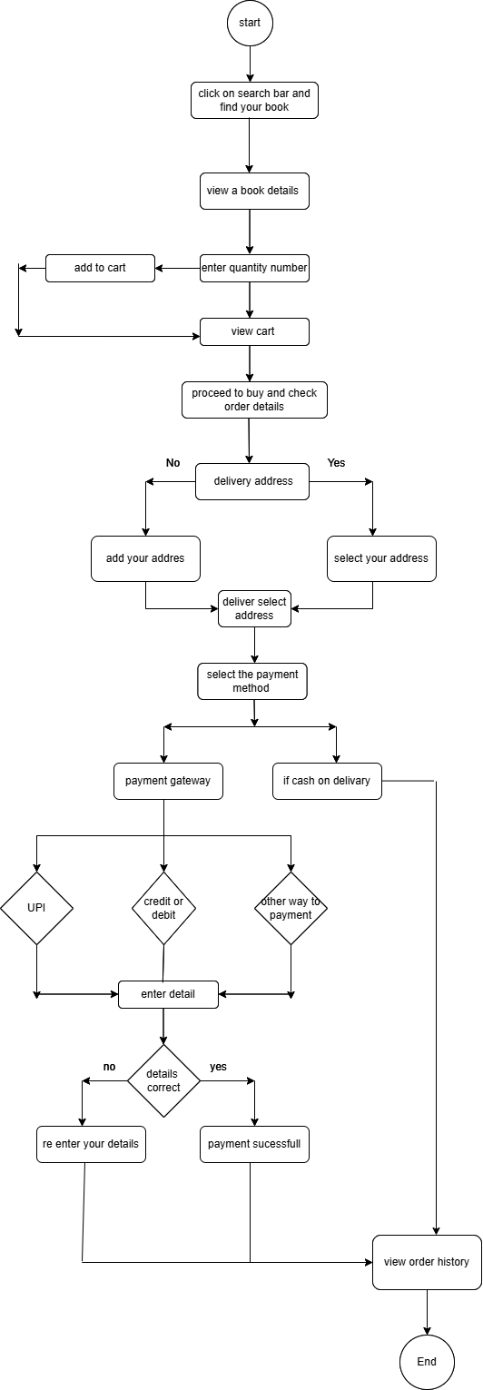

**17.draw usecase on online bill payment system (paytm).**

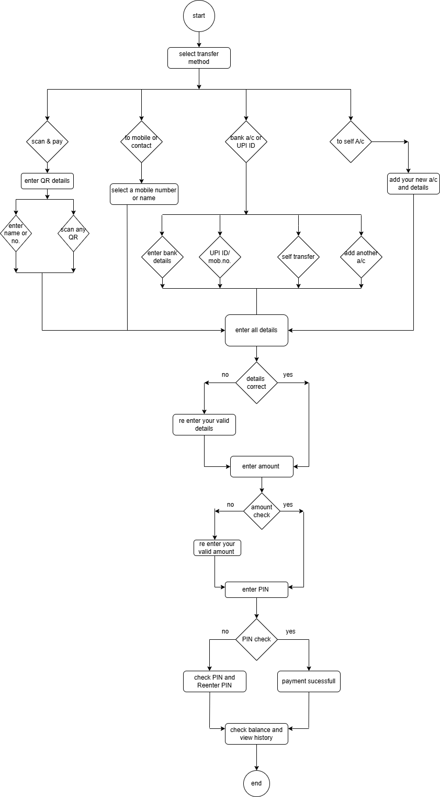

**18.draw a usecase on online shopping product by payment gate way**

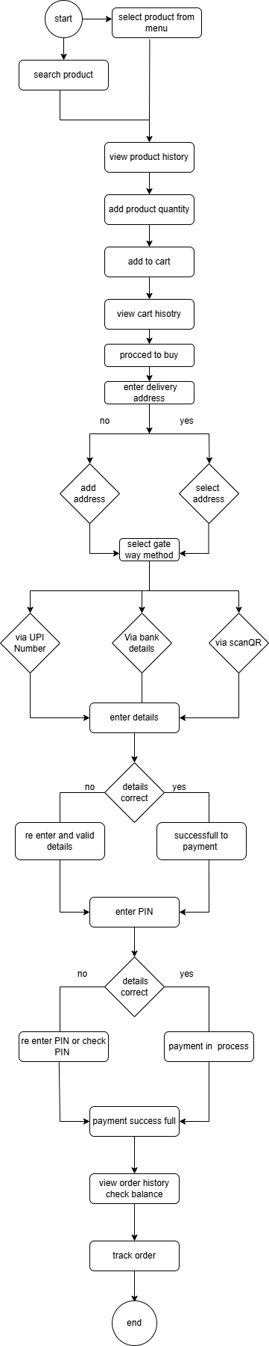

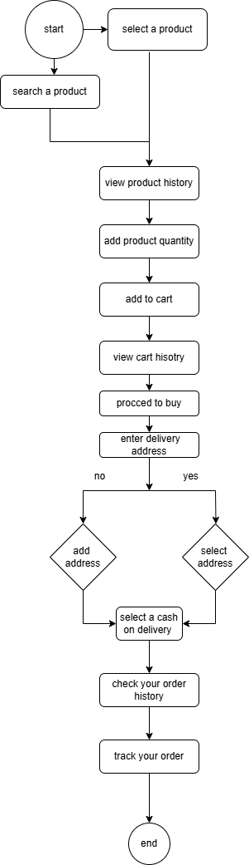

**19. draw a use case online shopping by COD**